Project Design Phase-II
Technology Stack (Architecture & Stack)

Date | 15 March 2025
Team ID
Project Name | RentEase - House Rent Management System
Maximum Marks | 4 Marks

Technical Architecture:
The Deliverable shall include the architectural diagram as below and the information as per the table1 & table 2
Example: Order processing during pandemics for offline mode
Reference: https://developer.ibm.com/patterns/ai-powered-backend-system-for-order-processing-during-pandemics/
Guidelines:
Include all the processes (As an application logic / Technology Block)
Provide infrastructural demarcation (Local / Cloud)
Indicate external interfaces (third party API’s etc.)
Indicate Data Storage components / services
Indicate interface to machine learning models (if applicable)


Table-1 : Components & Technologies:
S.No | Component | Description | Technology
- 1 | User Interface | How the tenant/admin interacts with the app | React.js, Tailwind CSS, Vite, Lucide Icons
- 2 | Application Logic-1 | Core REST API routing and business logic | Node.js, Express.js
- 3 | Application Logic-2 | Authentication & role-based access control | JWT (jsonwebtoken), bcryptjs
- 4 | Application Logic-3 | Property image upload handling | Multer (multipart/form-data)
- 5 | Database | Stores users, properties, and bookings | MongoDB with Mongoose ODM
- 6 | Cloud Database | Managed cloud database service | MongoDB Atlas
- 7 | File Storage | Stores uploaded property images | Local /uploads directory (Multer static serve)
- 8 | External API-1 | Not used in current scope | N/A
- 9 | External API-2 | Not used in current scope | N/A
- 10 | Machine Learning Model | Not used in current scope | N/A
- 11 | Infrastructure (Server / Cloud) | App deployment  Local Server Configuration: Node.js v16+, Express on port 5000  Cloud Server Configuration: Deployable to Render/Railway (API) + Vercel/Netlify (frontend) | Local Node server / Cloud PaaS

Table-2: Application Characteristics:
S.No | Characteristics | Description | Technology
- 1 | Open-Source Frameworks | Frameworks used across the stack | React.js, Express.js, Mongoose, Tailwind CSS
- 2 | Security Implementations | Password hashing, token-based auth, protected routes | bcryptjs hashing, JWT verification middleware
- 3 | Scalable Architecture | 3-tier architecture with a stateless API layer | Horizontally scalable Express instances behind a load balancer
- 4 | Availability | Managed cloud database with replication | MongoDB Atlas (built-in replica sets & backups)
- 5 | Performance | Fast bundling, indexed queries, static asset caching | Vite build tooling, MongoDB indexes on search fields

References:
https://c4model.com/
https://developer.ibm.com/patterns/online-order-processing-system-during-pandemic/
https://www.ibm.com/cloud/architecture
https://aws.amazon.com/architecture
https://medium.com/the-internal-startup/how-to-draw-useful-technical-architecture-diagrams-2d20c9fda90d

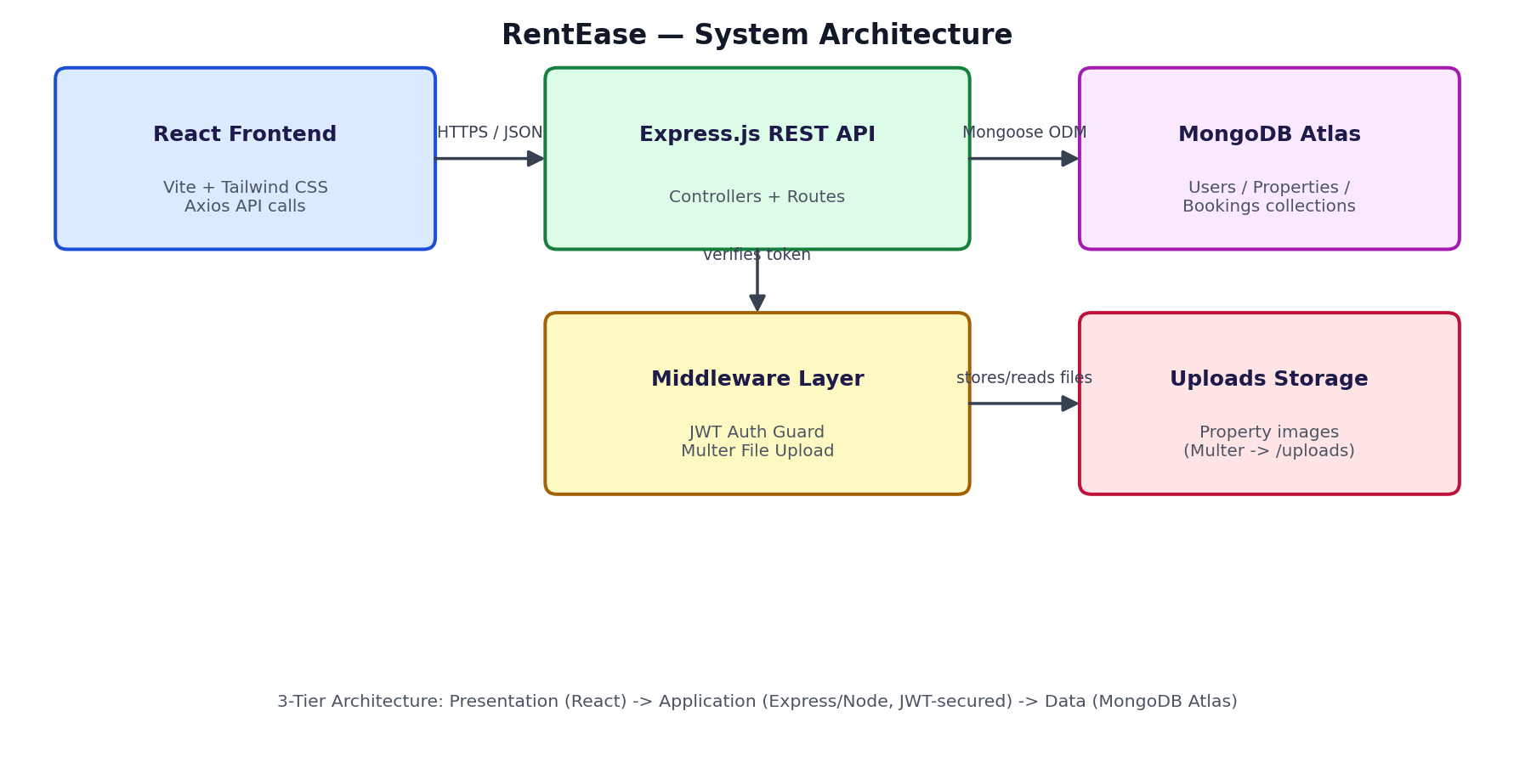
RentEase 3-tier architecture: React client -> Express/Node REST API (JWT-secured) -> MongoDB Atlas

